Week 1

EDA and Research Questions

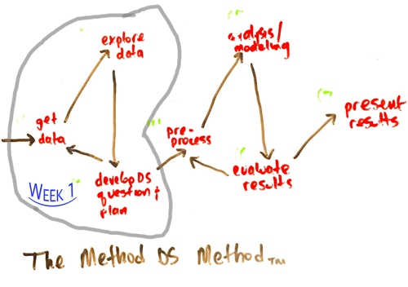  
Illustration 1: Week 1 - MDS Method

# 

# Problem Statement

Create a successful app or website that accentuates positive news according to the tastes and preferences of a user.

# Research Questions

* What are the emotions that the articles or news need to elicit to ensure enhanced emotional health?
* What will be the business model / unit economics?
* What is the best set of filters to offer the users a curated newsfeed? How do we define “best” in this context?
* Market survey: What are some similar products out there? What is the current market size?
* What can be the “X” factor differentiating our product from others? Where can the product “fit” in the current ecosystem?
* Can we partner with “activities” that are associated with wholesomeness? Eg. Yoga, Environmentalism, Hiking, Sports, Volunteering, Farmer’s Market groups etc.
* Do we need to ensure political neutrality to target all sections? What is the target demography?
* What are the standard industry techniques used for curating a filtered newsfeed?
* What kind of Minimum Viable Product can we build and how can we validate it?
* What are the metrics needed to measure success?
* What is the marketing strategy best needed to promote this product?
* How can we ensure user retention? How do we make them crave our product?
* In the long term, how do we measure whether this product has led to a greater wholesome state of mind for the user? How do we measure the product has succeeded in its mission?

# Emotions or Qualities to Elicit

Compassion Goodwill Joy Calm Peace Optimism Reflection Discipline Appreciation Conscientiousness Openness Prudence Self-respect Generosity Moderation Resilience Equanimity Tolerance Gratitude Urgency

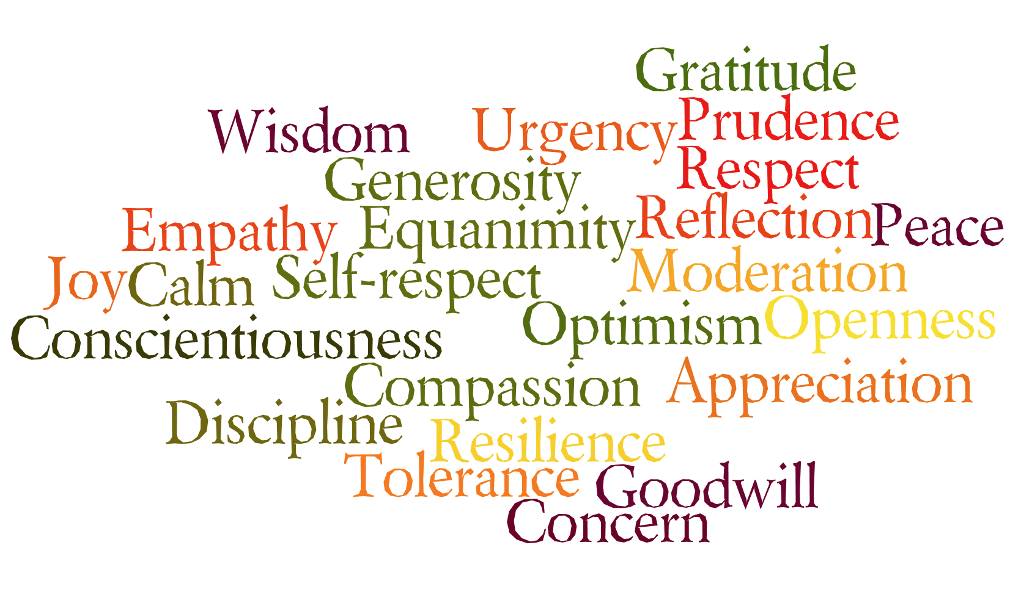  
Illustration 2: Positive Emotions Word Cloud

# Market Research:

A simple Google search for *positive news* creates the following results:

|  |  |  |  |
| --- | --- | --- | --- |
| **URL** | **What is it?** | **What is the business model?** | **What are the categories?** |
| <https://www.positive.news/> | Website: Good news about good things.  UI/UX: Simple and elegant | Online magazine subscription and donation. | Society, Economics, Science, Environment, Lifestyle, Perspective |
|  |  |  |  |
|  |  |  |  |
|  |  |  |  |
|  |  |  |  |
|  |  |  |  |
|  |  |  |  |
|  |  |  |  |
|  |  |  |  |